Nomination Form
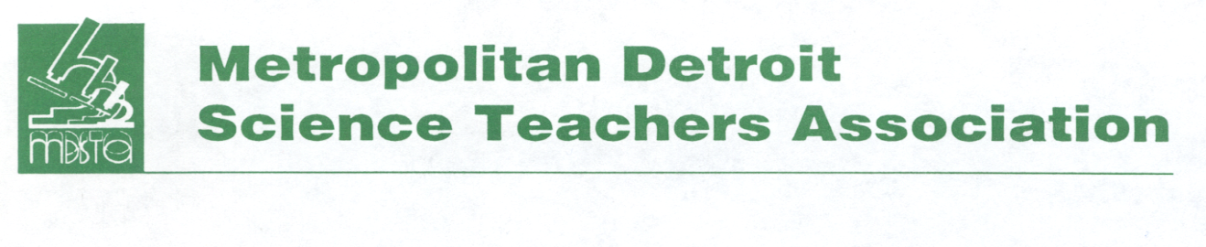
Outstanding Science Educator Award Application
The Metropolitan Detroit Science Teachers Association continues to promote and recognize excellence in teaching. Please help us to identify those friends and colleagues whose work is outstanding by completing the nomination form.

Selection Criteria (Information for Bio)
- Nominees must be currently a dues paying member of MDSTA at the time of nomination.
- Nominees must be in science education.
- Nominees must have made significant contributions in the classroom and in other professional activities.
One or more of the following may be include:
- Idea sharing with colleagues
- Presentations at professional workshops or conferences
- Written or developed curriculum materials
- Participation in extracurricular science activities
- Served on boards of professional STEM organizations

Name of Nominee: _____________________________________________________________________
Home Address: ________________________________________________________________________
City, State, Zip: ________________________________________________________________________
Email address: _________________________________________________________________________
Home or cell phone: ____________________________________________________________________
Name of School and District: _____________________________________________________________
Award Category (Circle One) Elementary Middle School High School
Date: ________________________________________________________________________________
Your Name: ___________________________________________________________________________
Your Phone: ________________________________ Email: _____________________________________
Please submit three letters of support and a one-page biography of the nominee’s professional contributions along with this form. Questions? Contact Debby Peters at 248.642.6326 or djapeters@gmail.com.

Nominations are accepted from November through April for award consideration for the current school year. All materials must be postmarked by April 1st and mailed to:
MDSTA, Attention OSEA, P.O. Box 111, Southfield, MI 48037 or
email to: mdsta1941@gmail.com

