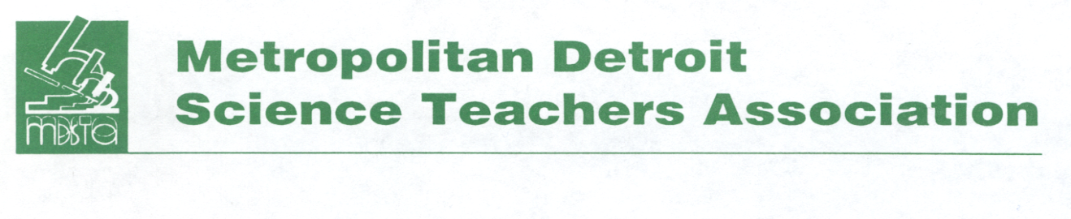
Ellen Daniel-Jones Distinguished Service Award

A devotion to children and learning... those words describe this phenomenal woman. She was extremely dedicated to education and a consummate professional. In 1964 Ellen began her teaching career in the Detroit Public Schools System. She taught at every school level, elementary through high school. She served as a Science Department Head in 1987, and moved into the position of Science Curriculum Supervisor in 1994 where she continued to serve until her untimely passing.

Ellen prized learning. As a student at the Alger Elementary School, her love for science and mathematics were nurtured and developed. Ellen matriculated through the Detroit Public Schools, graduating in 1960 from Northwestern High School. Ellen’s love for learning continued in college, where she received her Bachelor of Science degree from Michigan State University in 1964 and a Master of Education degree from the University of Michigan in 1976.

If you knew Ellen, you were keenly aware of her dedication, love and untiring efforts to remain at the forefront of emerging techniques and technologies to provide the very best in classroom instruction for the students of the Detroit Public Schools. She was passionate about education, devoting more than 40 years to the Detroit Public School System. Ellen attended conferences and workshops across the state. This allowed her to stay abreast of curriculum, educational trends, strategies and resources she could share with teachers in the Detroit Public School District and teachers of other school districts, which she coached and mentored.

In 2004, she was presented with the MDSTA “Distinguished Service Award” in recognition of her outstanding and selfless devotion to the teachers served by the Metropolitan Detroit Science Teachers Association, where she served on the board of Directors as Executive Secretary. She also enjoyed memberships in the Michigan Science Teachers Association and the National Science Teachers Association.

The Metropolitan Detroit Science Teachers Association recognizes the values, dedication and leadership of teachers who exhibit these qualities by renaming this award “The Ellen Daniel-Jones Distinguished Service Award,” in honor of this dedicated educator.
Ellen Daniel-Jones Distinguished Service Award
Nomination Form

Eligibility – The nominee must be a current member of MDSTA, be actively involved with pre-K - college as a teacher, mentor, or serve as an administrator.

If you know an educator deserving of this award please complete this nomination form along with one page which includes the following: Background information on the nominee and explain briefly what makes this nominee a good candidate for “The Ellen Daniel-Jones Distinguished Service Award.” You may use examples such as: awards and achievements, leadership, presentations, classroom or educational contributions to students or teachers.

A committee of the MDSTA Board will review all nomination forms in February. The nominee will be notified in March. The award will be presented to the selected nominee at the general membership meeting in May.

All completed applications must be emailed or postmarked by January 31st
Please send this completed nominee form to: MDSTA, Att: ED-JDSA, P.O. Box 111, Southfield, MI or email to mdsta1941@gmail.com

Questions? Contact Debby Peters at 248.642.6326 or djapeters@gmail.com

Name of Nominee________________________________________________________________

Home Address ________________________ __City__________________ ____State_____ _____

Phone Number___________________________ _Email _________________________________

School Name ______________________________ School District __________________________

Nominated by___________________________ Date submitted__________________

This form together with your one page nomination information sheet constitutes a complete application.

Ellen Daniel-Jones Distinguished Service Award
Nomination Form

Nominee Background Information

Explanation of Service

